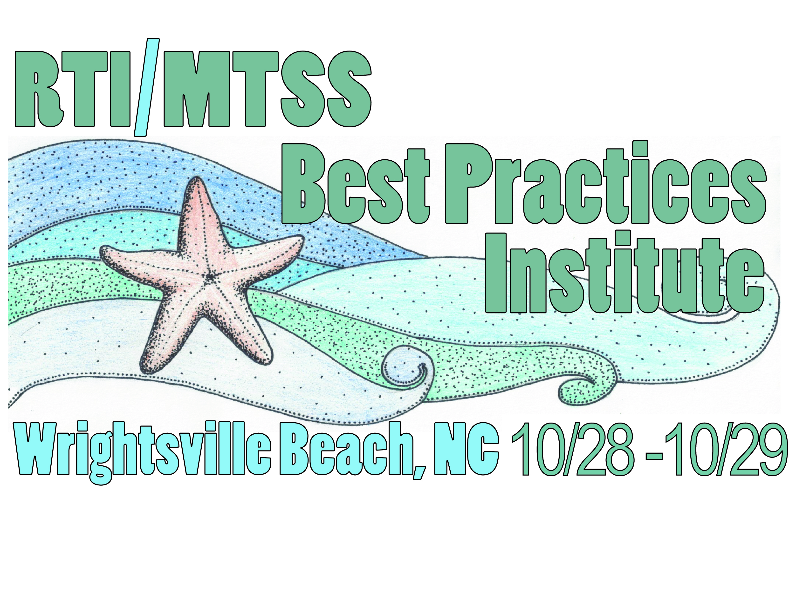 |  |  | RTI/MTSS Practices Institute  Tuesday October 29, 2019  AGENDA
Time | Location |  |  | Event
7:30-8:15 | Lumina Ballroom |  |  | Continental Breakfast (pastries, fruit, juices, and coffee)
8:15-10:15 | Whole Group Keynote Session One
  Topic | Facilitator | Location
  Doing What Works: Leading an MTSS Effort for Sustained System Improvement Over Time | Dr. Amanda VanDerHeyden | Masonboro Room
10:15-10:30 | Lumina Ballroom | Break
10:30-12:30 | Whole Group Keynote Session Two
  Topic | Facilitator | Location
  The Next MTSS Frontier: Mathematics | Dr. Amanda VanDerHeyden | Masonboro Room
12:30 | Adjourn – Lunch on your own

